A Mini Project Report

On

“Anaemia Prediction Model using Explainable AI”
submitted in partial fulfilment of the requirements for the award of degree of

Bachelor of Engineering
In
Computer Science and Engineering
Submitted by

Mohammad Muddabir Ahsan 1608-23-733-176

Under the Guidance of
Dr. L Raghavendra Raju
Associate Professor

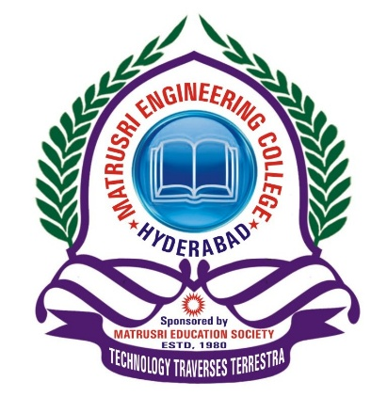

Department of Computer Science and Engineering
Matrusri Engineering College
Affiliated to Osmania University, Approved by AICTE
Saidabad, Hyderabad - 500059
2025-2026
Department of Computer Science and Engineering
Matrusri Engineering College
Affiliated to Osmania University, Approved by AICTE
Saidabad, Hyderabad - 500059

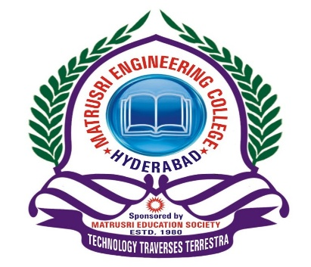
CERTIFICATE
This is to Certify that A Mini Project report entitled “Anaemia Prediction Model using Explainable AI” is being submitted by Mohammad Muddabir Ahsan (1608-23-733-176) in partial fulfilment of the requirement of the award for the degree of Bachelor of Engineering in “Computer Science and Engineering” O.U., Hyderabad during the year 2025-26 is a record of Bonafide work carried out by him/her under my guidance. The results presented in this mini project report have been verified and are found to be satisfactory.

Project Guide HOD

Dr. L Raghavendra Raju Dr. T.Raghunadha Reddy
Associate Professor Assoc. Professor & Head Dept. of CSE Dept. of CSE

External Examiner(s):___________________________________

